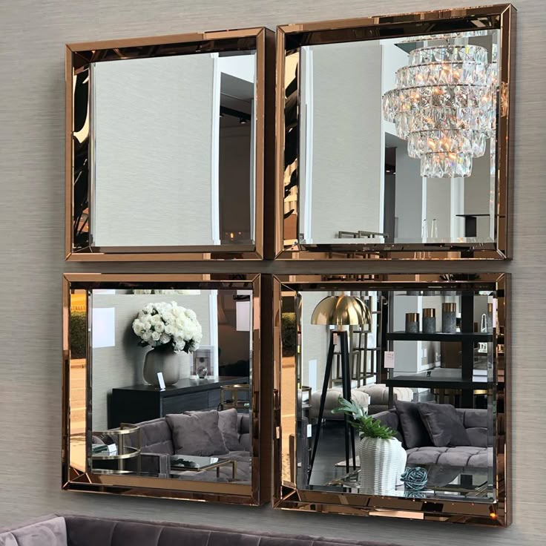**Structured Elegance with Timeless Square Mirrors**

In the world of interior design, structure brings clarity — and **Square Mirrors** offer just that. With their clean lines and balanced shape, square mirrors introduce a sense of order and symmetry to any room. Whether used as a single statement piece or as part of a stylish mirror arrangement, these mirrors enhance the aesthetic of your space with quiet confidence.

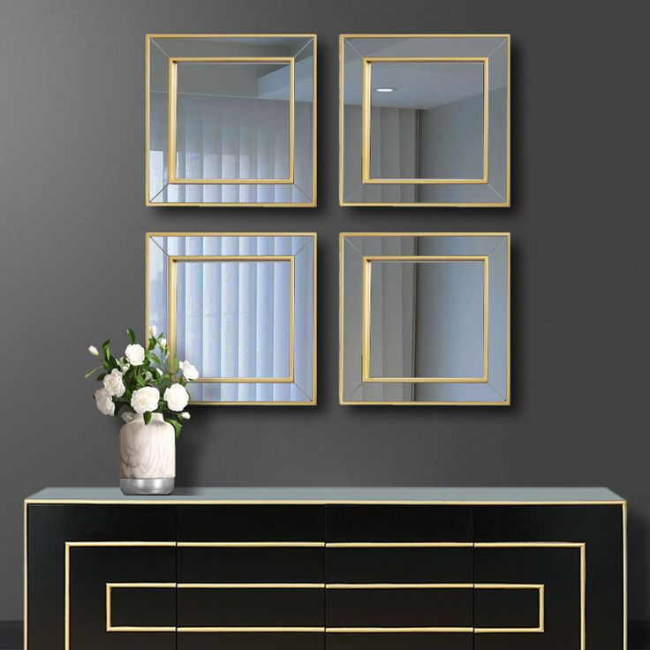Our Square Mirrors come in a wide range of finishes — from sleek black or brushed silver metal frames to warm natural woods and contemporary frameless options. Crafted using high-quality, distortion-free glass, these mirrors deliver sharp reflections and lasting durability. Their geometric precision makes them ideal for modern homes, minimalistic designs, or spaces that celebrate sharp, clean lines.

Perfect for bathrooms, bedrooms, entryways, and living rooms alike, square mirrors reflect both light and style. They open up compact areas and add definition to larger walls, working equally well in solo use or grouped gallery-style layouts. The simple shape makes them incredibly versatile — adapting to both bold and subtle décor themes.

Add clarity, balance, and modern refinement to your home with a mirror that reflects both form and function.